 | BAHRIA UNIVERSITY  (Karachi Campus)  Department of Software Engineering  Lab Project – FALL 2024  COMPLEX ENGINEERING PROBLEM
Course Title: Software Construction Course Code: CEN 221
Class: BSE – 5(A/B/C) Shift: Morning
Course Instructor: Dr.hussain Date: 22nd December, 2024
Lab Instructor: Engr. asma shaheen Max. Marks: 30 Marks

Instructions:
- This is a Complex Engineering Problem Lab Project.
- Demonstration of Project will be on the week before Theory Exam.
- Report will be submitted on LMS in given Time Slot.
- Report format is uploaded on LMS
- If you submit your Report after the given deadline then 1 Marks will be deducted for the late submissions.
- Group Members Should be 3 or 2.
- Presentation must be of 5 min for project demonstration.
Lab Project Task: [CLO 3 ,15.0 marks]
The Student should fulfill the following requirements in their lab project.
The application should implement networking features learned in the lab, such as message routing, data encryption, and secure communication. It should use appropriate protocols (like TCP/IP or HTTP), networking devices (like routers and servers), and tools like Packet Tracer or similar network simulation software for visualizing the network architecture.

Lab Project Report: [CLO 5,5.0 marks]
Lab Project Proposal: [CLO 55.0 marks]
Lab Project VIVA: [CLO 6,5.0 marks]


BAHRIA UNIVERSITY, Karachi Campus
Department of Software Engineering
REPORT
Course Title: Course Code:
Course Instructor: Class: BSE- (A/B/C)
Lab Instructor: Engr. Asma Shaheen Name: ______________________

PROJECT TITLE:

GROUP MEMBERS LIST:
S.NO | Enrollment | Name | Email
01 | 02-131222-003 | Hira Raheel | hiraraheelpasha@gmail.com
02 | 02-131222-083 | Fahad Gillani | fahadgilani08@gmail.com

Submission Date: 1/3/2025

Contents
ABSTRACT 4
1. INTRODUCTION 5
1.1. Introduction 5
1.2. Problem Statement 5
1.3. Proposed Solution 5
2. DESIGN 6
2.1. Workflow Diagram 6
2.2. User Interfaces (Packet tracer, Physical View) 6
2.3. Network Diagram (Packet tracer, Logical View) 8
3. METHODOLOGY 8
3.1 Technologies Use 8
3.2. Network Communication Methodology 9
3.3. Commands 10
4. CONCLUSIONS AND FURTHER WORK 17
5. REFERENCES 17

ABSTRACT

The proposed network design for Tokyo NetConnect aims to establish a secure, scalable, and efficient communication system within the organization. The project leverages Cisco devices to build a network that adheres to the principles. By implementing robust network segmentation and security measures, the project ensures safe and seamless interaction among the company’s departments, on-premise systems, and cloud resources. This solution will empower Tokyo NetConnect to maintain business continuity while meeting its operational and security requirements.

INTRODUCTION

Introduction

The rapid growth of Tokyo NetConnect, a telecommunication company in Japan, requires a secure, scalable, and reliable network system to support the increasing demand for its IT services. Located in Tokyo’s iconic Shibuya district, Tokyo NetConnect operates multiple departments across two floors of Sakura Plaza. The network system must safeguard the confidentiality, integrity, and availability of data while enabling seamless communication, secure access to cloud resources, and efficient IT operations. This project focuses on designing and implementing a secure network infrastructure for the company, incorporating industry standards and best practices to meet the organization’s unique requirements.

Problem Statement
The rapid expansion of Tokyo NetConnect has created a pressing need for a network infrastructure that can:
- Support secure, efficient communication across departments.
- Provide reliable access to on-premises systems and cloud resources.
- Ensure scalability for future growth and robust security to protect sensitive data.

Proposed Solution
To address the above challenges, a comprehensive network design leveraging Cisco devices has been proposed. This solution focuses on robust network segmentation, secure connectivity to cloud resources, and implementation of advanced security measures, including traffic inspection, VLANs, and access control. The network will ensure seamless interaction across departments while meeting operational and security requirements.

DESIGN

Workflow Diagram
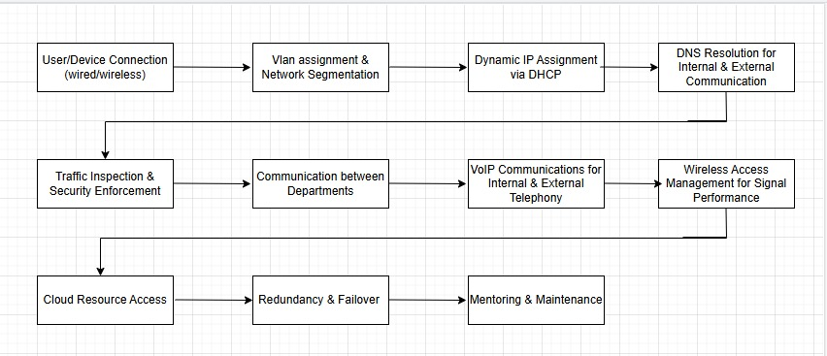

User Interfaces (Packet tracer, Physical View)
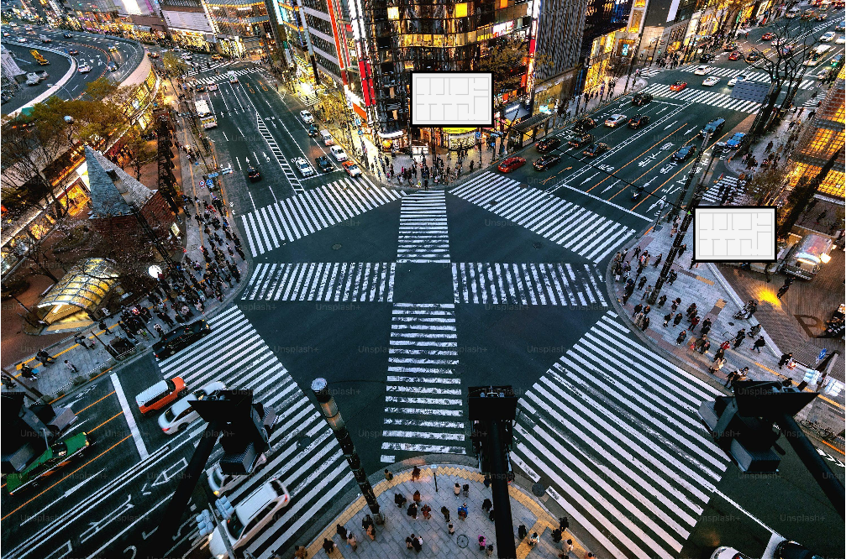

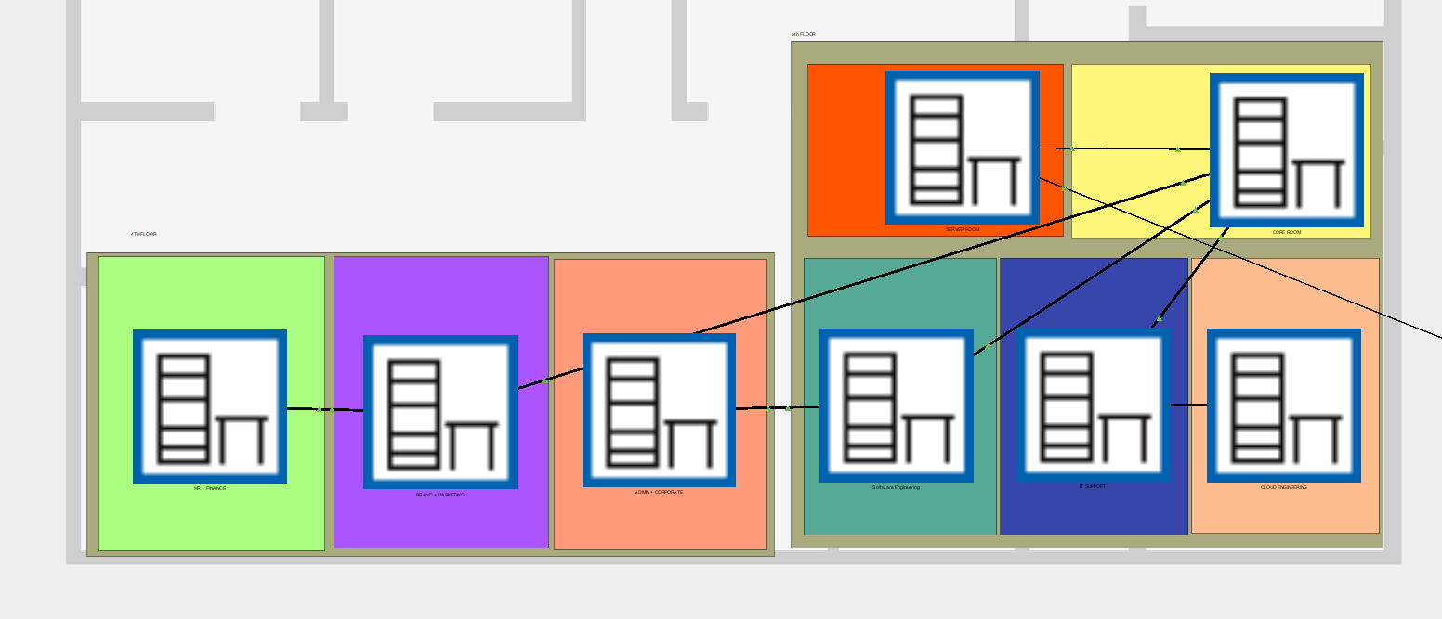

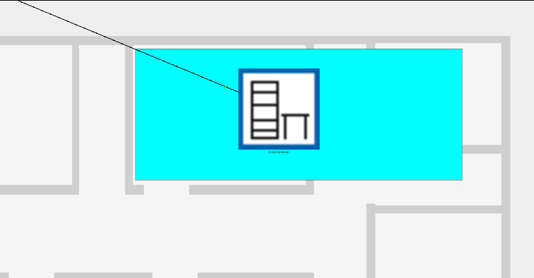

Network Diagram (Packet tracer, Logical View)
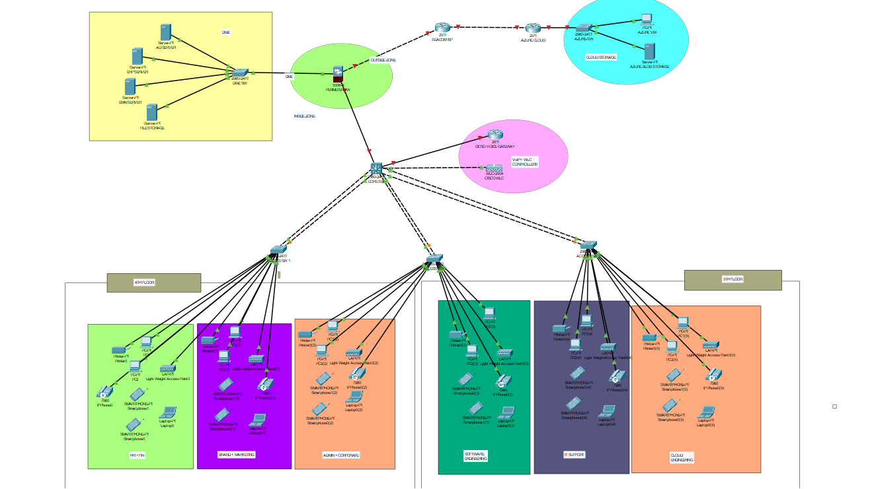

METHODOLOGY

Technologies Use
Category | Technology/Concept | Purpose/Description
Networking Devices | Cisco Routers | Directs data packets between different networks efficiently.
 | Cisco Switches | Connects devices within a LAN to enable communication.
 | Cisco ASA Firewall | Provides network security by filtering traffic and preventing intrusions.
 | Cisco Voice Gateways | Converts voice signals between traditional telephony and VoIP networks.
 | Cisco Wireless LAN Controllers (WLC) | Manages and optimizes wireless network devices centrally.
Protocols | Dynamic Host Configuration Protocol (DHCP) | Automatically assigns IP addresses to devices on the network.
 | Domain Name System (DNS) | Resolves human-readable domain names into IP addresses.
 | Open Shortest Path First (OSPF) | Determines the most efficient routing path between network nodes.
 | Voice over Internet Protocol (VoIP) | Facilitates voice communication over IP networks.
Configuration Tools | Cisco Packet Tracer | Simulates network configurations and tests network behavior.
 | Command-Line Interface (CLI) for Cisco devices | Enables detailed and precise device configuration and management.
Additional Concepts | Network Address Translation (NAT) | Translates private IP addresses to public IPs for internet access.
 | VoIP implementation | Deploys voice communication capabilities over IP-based networks.

Network Communication Methodology
The network communication process is structured to ensure seamless, secure, and efficient interactions between departments and external resources. Key methodologies include:
- Intra-department Communication: Departments such as HR/Finance, IT Support, and Cloud Engineering communicate within their designated VLANs, ensuring traffic isolation and security. This segmentation prevents unauthorized access and minimizes broadcast traffic.
- Inter-department Communication: Communication across departments is facilitated through Layer 3 inter-VLAN routing, governed by access control lists (ACLs) on the Cisco ASA Firewall. These ACLs ensure that only permitted traffic, as per role-based access control policies, can traverse between VLANs.
- Cloud Connectivity: Secure communication with Microsoft Azure resources is established using SSL encryption and NAT for address translation. This allows developers and engineers to access virtual machines and cloud storage without exposing sensitive internal IP addresses.
- Firewall Policies: The firewall inspects traffic and enforces security policies, such as restricting HR/Finance VLAN access to sensitive databases while permitting general internet usage.
- Redundancy and Failover: Redundant links and devices ensure uninterrupted communication by automatically switching to backup paths in case of failures.

Commands

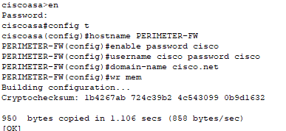
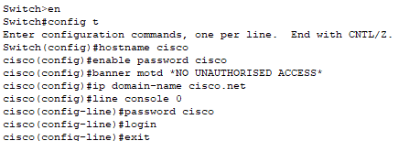
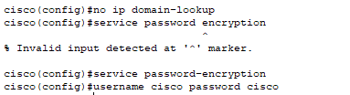
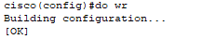
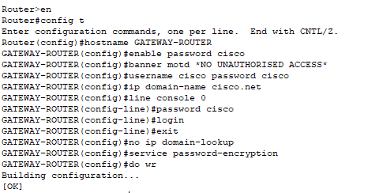
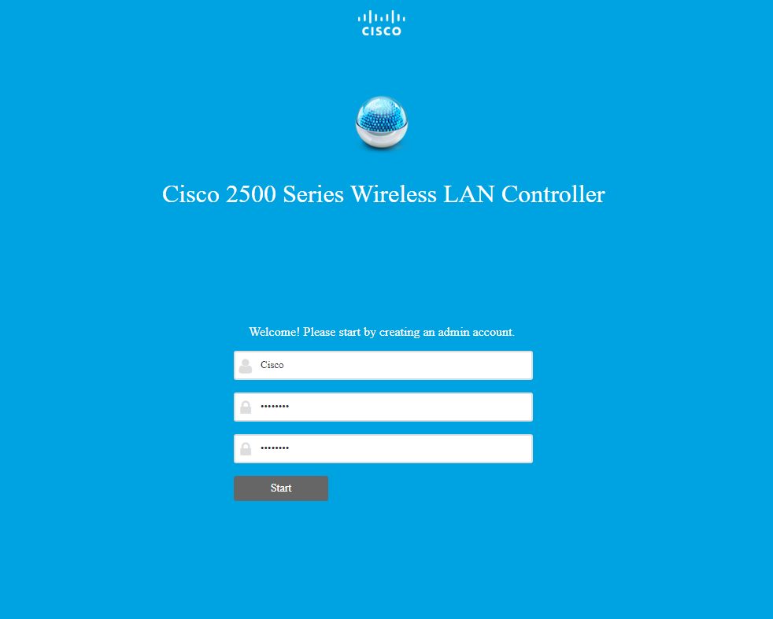

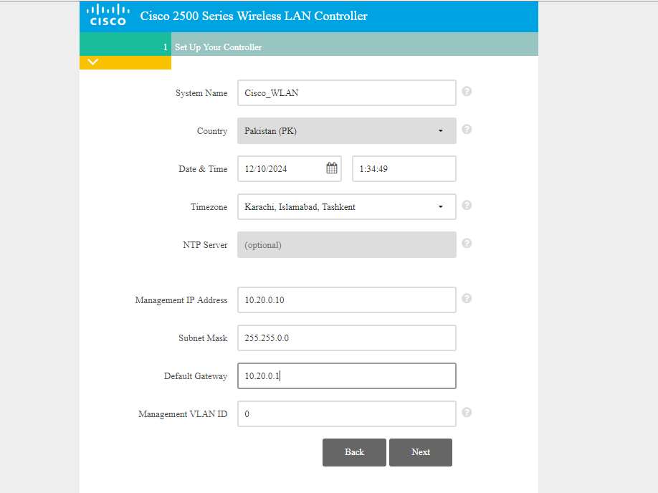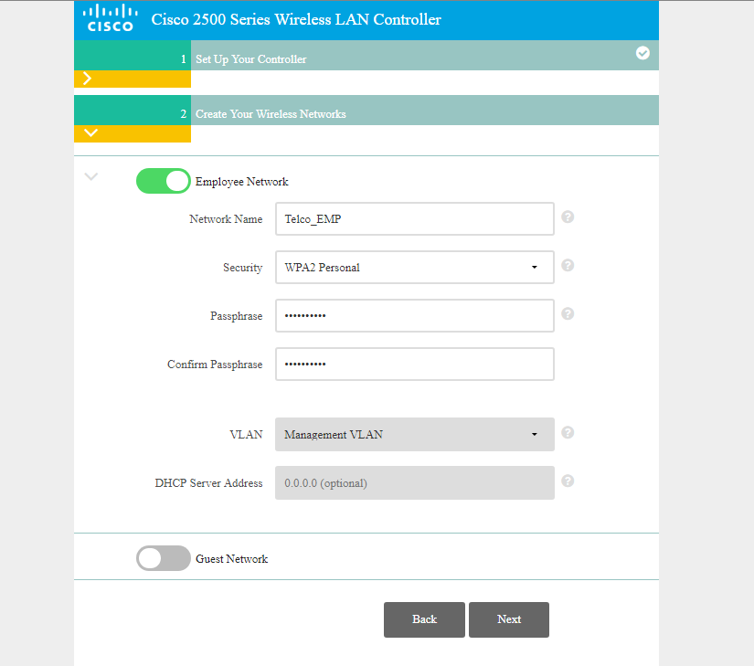
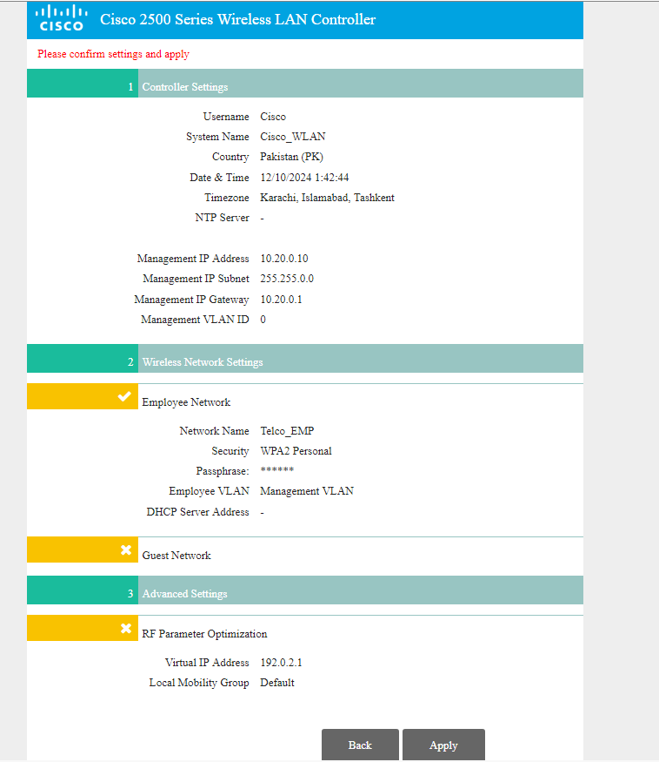
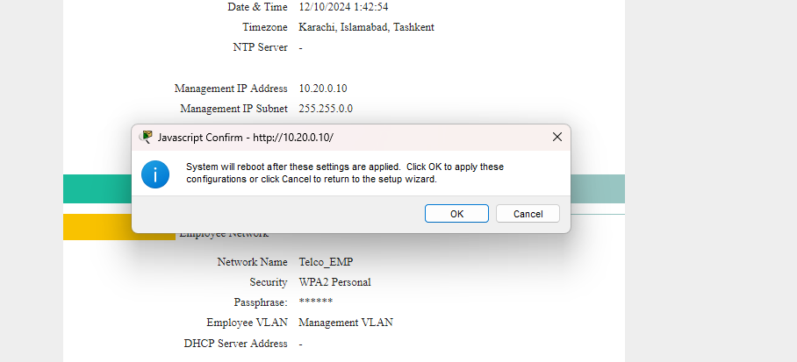
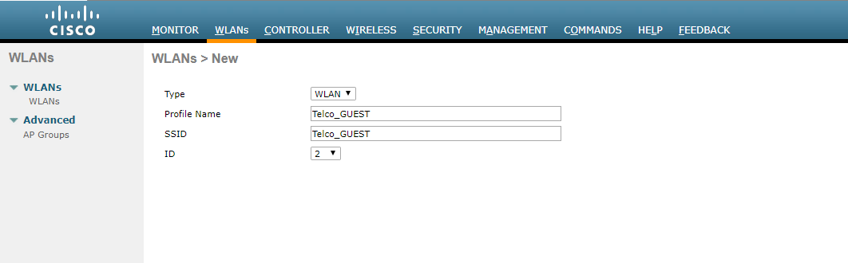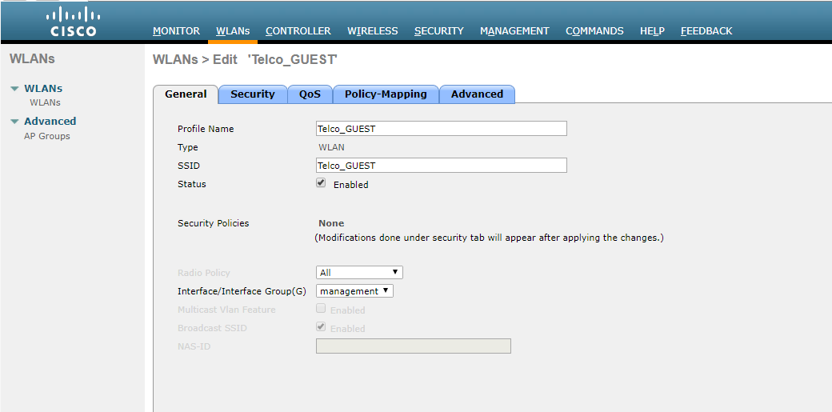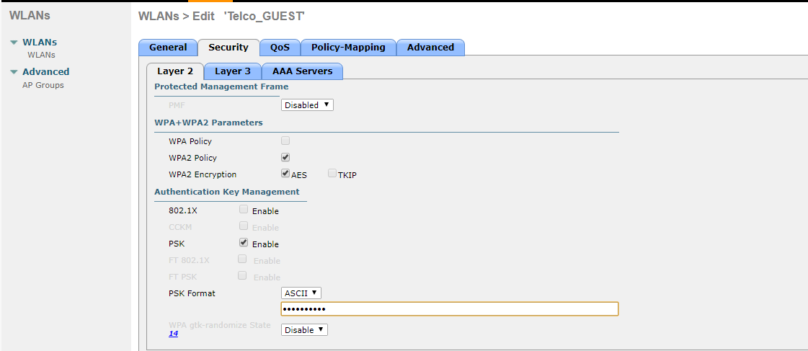
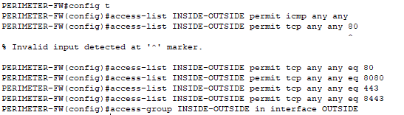
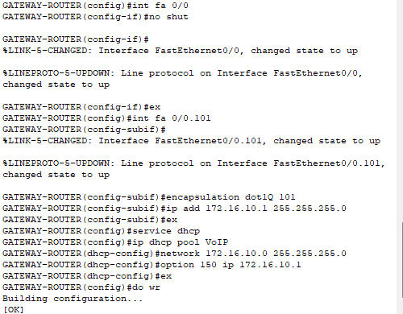
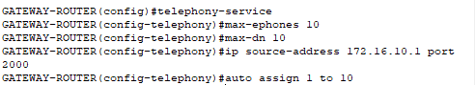
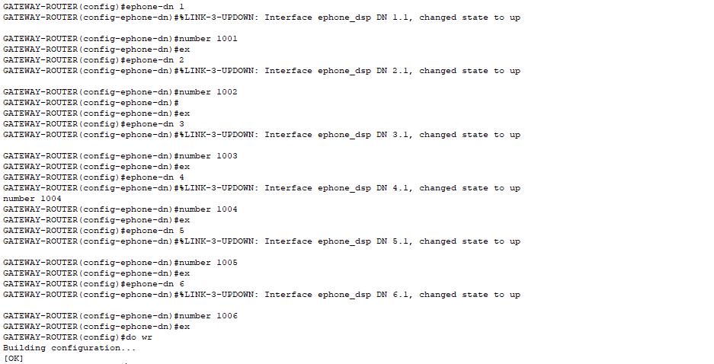

CONCLUSIONS AND FURTHER WORK
The proposed network design for Tokyo NetConnect addresses the company’s need for a secure, scalable, and reliable communication system. By implementing VLANs, firewall policies, and secure cloud access, the design ensures optimal performance, security, and scalability. The logical and physical topologies reflect a future-proof architecture capable of supporting the company’s growth.
Future improvements could include:
- Integration of advanced intrusion detection systems (IDS) for enhanced security.
- Regular performance monitoring and capacity planning.
- Deployment of additional redundancy mechanisms to improve fault tolerance.

REFERENCES
https://github.com/Fahad-Gillani/University-Projects/blob/master/PROJECT.zip

